16.9: Solving Eq. (16.10) for the temperature,

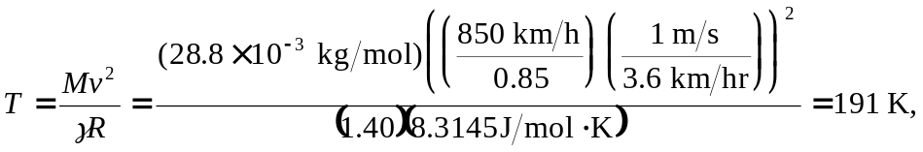

or 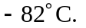 b) See the results of Problem 18.88, the variation of atmospheric pressure with altitude, assuming a non-constant temperature. If we know the altitude we can use the result of Problem 18.88, 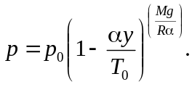 Since 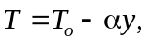 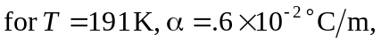and 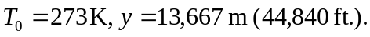 Although a very high altitude for commercial aircraft, some military aircraft fly this high. This result assumes a uniform decrease in temperature that is solely due to the increasing altitude. Then, if we use this altitude, the pressure can be found:

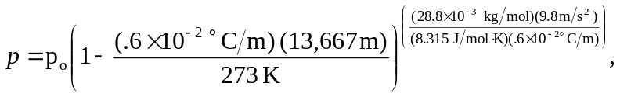

and 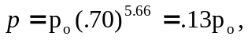 or about .13 atm. Using an altitude of 13,667 m in the equation derived in Example 18.4 gives 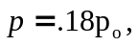 which overestimates the pressure due to the assumption of an isothermal atmosphere.

